BIOCHEMISTRY INSTRUMENTS & GLASSWARES FOR SPOTTING

INSRUMENTS USES

- Microscope -used to magnify small objects.
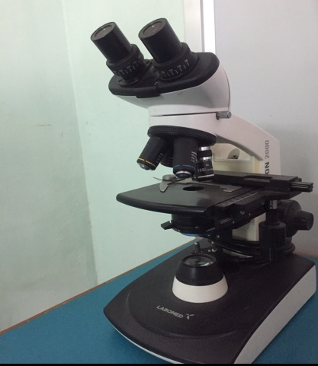
- Biochemical Analyser - to perform various tests like albumin tests, sugar level tests, creatinine etc, in the blood.
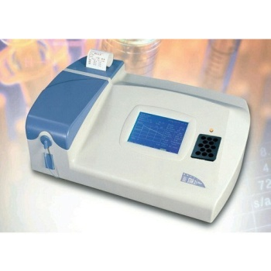

Digital pH meter - Used to measure hydrogen ion activity in solutions .
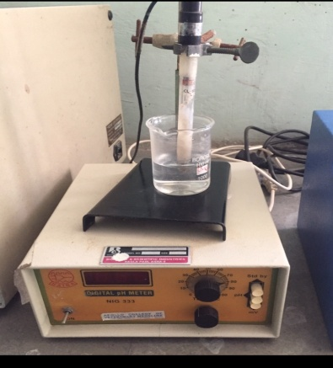
- Hot water bath- Used to incubate samples at a constant temperature over a long period of time.
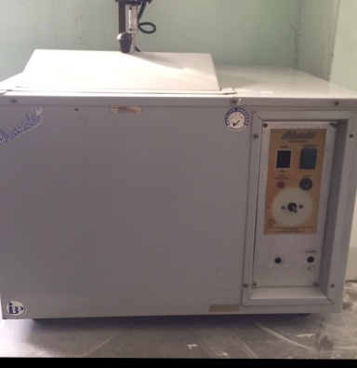

- Incubator – Used for providing temperature-controlled environment to support growth of microbiological cultures.
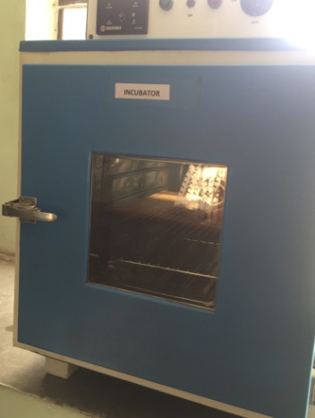

6.Colorimeter- used to measure the absorption of wavelengths of light by a sample at a given frequency (colour).
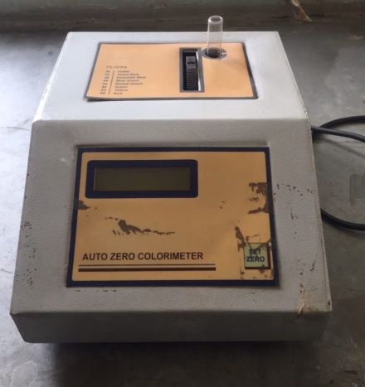

- Test tube holder- for holding test tubes.
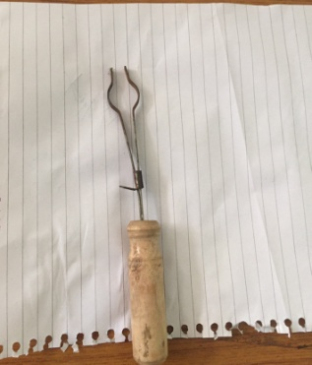

8.Folin wu tube- used to measure glucose.
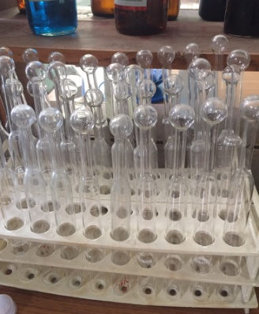

- Electronic weighing balance- for measuring quantity of sample / materials.

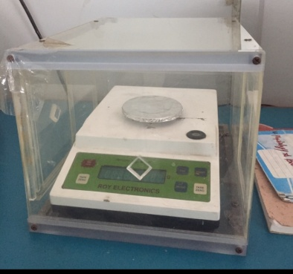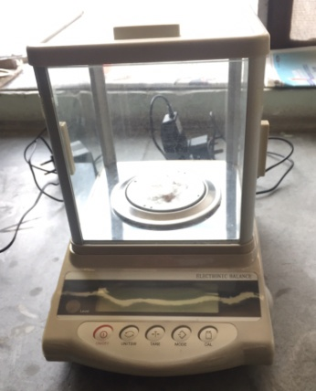

10.Centifuge machine-Used to separate fluids, gases, or liquids based on density.
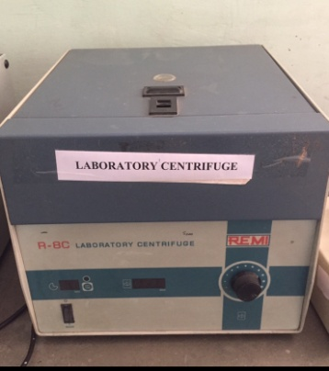

- Reagent bottle - used to store chemicals in liquid or powder form.
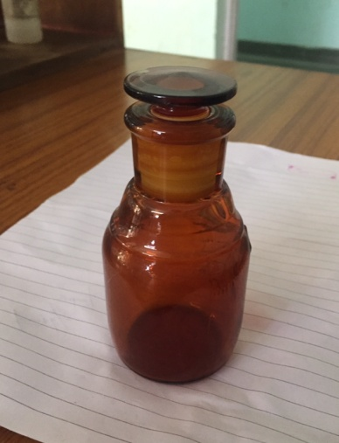

- Beaker- to hold liquid or solid samples.
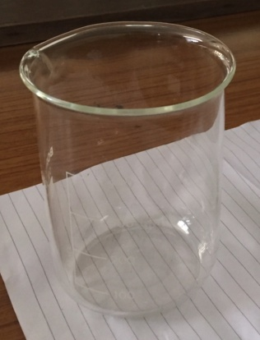

- Conical flask - used to hold and measure chemical liquid samples.
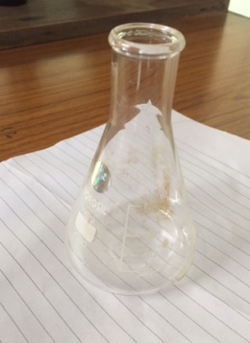

- Tong - used for grasping during various medical procedures.
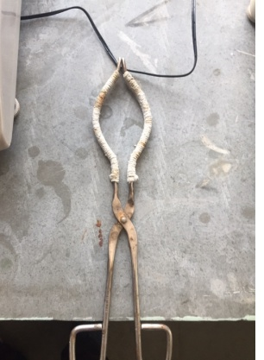

- Vortex mixture - mixing laboratory samples in test tubes, well plates, or flasks.

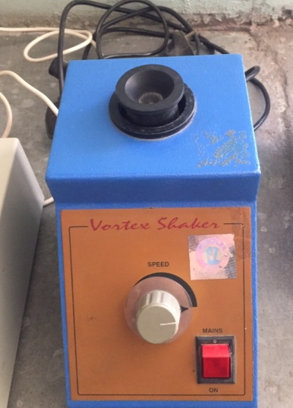

- Micro centrifuge machine- used for spinning a variety of samples at high speed.
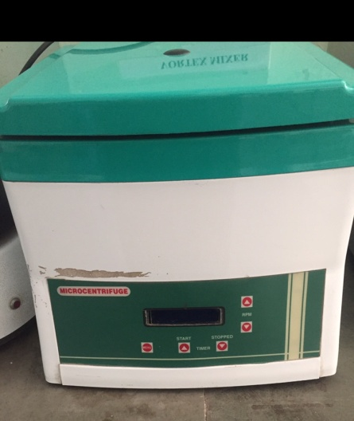

- Magnetic stirrer with hot plate- to conduct biological and chemical experiments by mixing two components.
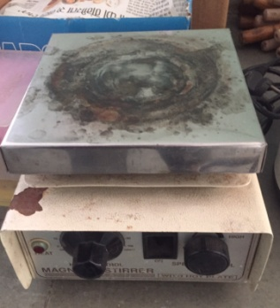
- Titration Assembly - quantitative chemical analysis to determine the concentration of an identified analyte (a substance to be analyzed).

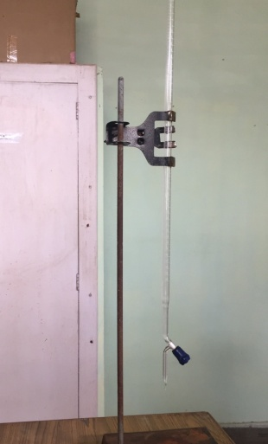
- Distillation process - used to isolate and purify liquids on the basis of their volatilities characterized by boiling point differences.
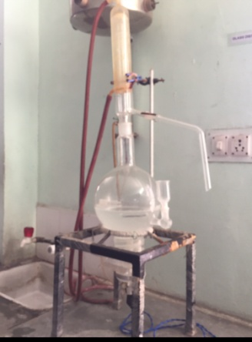

- EDTA Vial - to prevent blood samples from clotting and to remove calcium and lead from the body.
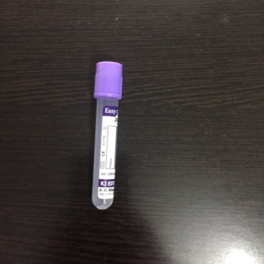

- Non EDTA / Serum vial –for obtaining serum samples.

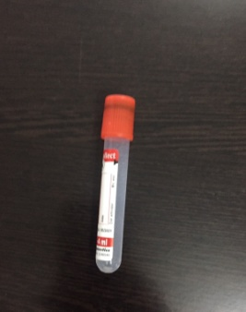

- Microtips in Tip box - used for handling fluids in small amounts.
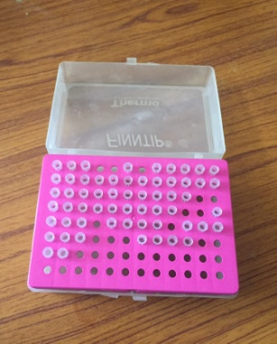
- Micropipettes - used to accurately and precisely transfer volumes of liquid in the microliter range.
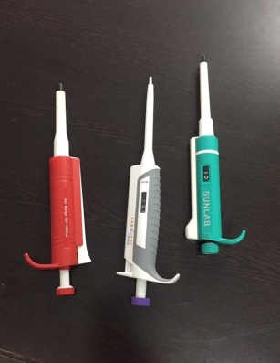

- Micro centrifuge tubes - storing liquid samples in small amounts.
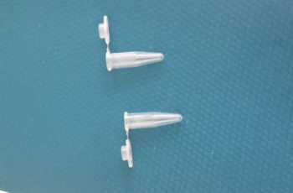
- Spatula - used to mix, spread and lift material including foods, drugs, plaster and paints.

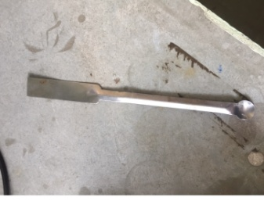
- Measuring cylinder. Used to measure the amount of fluid required for analysis.
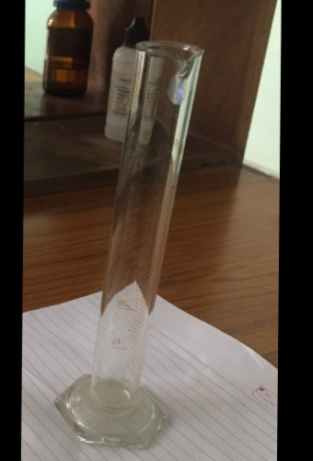

- Glass funnel - used to guard against spillage when pouring chemicals from one vessel to another.

